SupplementaryMaterial
Table S1. GenelistoftheNGSpenal
ABCA4 | ABCB6 | ABCC6 | ABCC6P2 | ABHD12 | ACBD5 | ACE | ACO2
ADAM9 | ADAMTS18 | ADAMTSL4 | ADGRA3 | ADGRV1 | ADIPOR1 | AGBL5 | AHI1
AHR | AIPL1 | AKT3 | ALDH1A3 | ALDH3A2 | ALMS1 | ANGPT2 | ANGPT4
ANO5 | AP3B1 | AP3D1 | APOE | ARHGEF18 | ARL13B | ARL2BP | ARL3
ARL6 | ARMC9 | ARMS2 | ARSG | ASRGL1 | ATF6 | ATOH7 | ATXN7
B9D1 | B9D2 | BAP1 | BBIP1 | BBS1 | BBS10 | BBS12 | BBS2
BBS4 | BBS5 | BBS7 | BBS9 | BCL10 | BEST1 | BHLHE23 | BLOC1S3
BLOC1S6 | BMP4 | C1QTNF5 | C2 | C3 | C5AR2 | C8orf37 | C9
CA4 | CABP4 | CACNA1F | CACNA2D4 | CAPN5 | CASR | CC2D2A | CCDC28B
CCT2 | CDH23 | CDH3 | CDHR1 | CEP104 | CEP120 | CEP164 | CEP19
CEP250 | CEP290 | CEP41 | CEP78 | CERKL | CFAP410 | CFB | CFH
CFHR1 | CFHR3 | CFHR4 | CFI | CHM | CIB2 | CLDN19 | CLN3
CLN5 | CLN6 | CLN8 | CLRN1 | CLUAP1 | CNGA1 | CNGA3 | CNGB1
CNGB3 | CNNM4 | CNOT9 | COL11A1 | COL11A2 | COL18A1 | COL2A1 | COL4A1
COL8A1 | COL9A1 | COL9A2 | CPLANE1 | CRB1 | CRX | CSN3 | CSPP1
CST3 | CTC1 | CTNNA1 | CTNNB1 | CTNS | CTSD | CTSF | CWC27
CX3CR1 | CYP4V2 | DHCR7 | DHDDS | DHX38 | DMD | DNAJC5 | DPP3
DR1 | DRAM2 | DTHD1 | DTNBP1 | EFEMP1 | ELOVL4 | EMC1 | ENPP1
ERCC2 | ERCC3 | ERCC4 | ERCC5 | ERCC6 | ERCC8 | EXOSC2 | EYA1
EYS | FAM161A | FBLN5 | FBN2 | FKRP | FKTN | FLVCR1 | FSCN2
FXN | FZD4 | GDF3 | GDF6 | GGCX | GMPPB | GNAT1 | GNAT2
GNB3 | GNPTG | GPR143 | GPR179 | GPR34 | GRK1 | GRM6 | GRN
GUCA1A | GUCA1B | GUCY2D | GUSB | HARS | HEXA | HEXB | HFE
HGSNAT | HK1 | HMCN1 | HMX1 | HPS1 | HPS3 | HPS4 | HPS5
HPS6 | HSPA5 | HTRA1 | IDH3B | IDUA | IFT140 | IFT172 | IFT27
IFT43 | IFT74 | IFT81 | IGFBP7 | IMPDH1 | IMPG1 | IMPG2 | INPP5E
INVS | IQCB1 | ITGA2B | ITGB3 | ITM2B | JAG1 | KCNJ13 | KCNV2
KIAA0556 | KIAA0586 | KIAA1549 | KIF11 | KIF7 | KIZ | KLHL7 | LAMA1
LARGE1 | LCA5 | LRAT | LRIT3 | LRMDA | LRP2 | LRP5 | LRP6
LRPAP1 | LYST | LZTFL1 | MAK | MAN2B1 | MANBA | MAPKAPK3 | MC1R
MCOLN1 | MERTK | MFN2 | MFRP | MFSD8 | MIR204 | MITF | MKKS
MKS1 | MLPH | MPDZ | MTHFR | MTTP | MVK | MYO5A | MYO7A
NAT8 | NBAS | NDP | NEK2 | NEUROD1 | NINL | NMNAT1 | NPHP1
NPHP3 | NPHP4 | NR2E1 | NR2E3 | NR4A3 | NRL | NUB1 | NXNL1
NYX | OAT | OCA2 | OFD1 | OPA1 | OPA3 | OPN1LW | OPN1MW
OPN1MW2 | OPN1SW | OR2W3 | OTX2 | P3H2 | PANK2 | PAX2 | PAX6
PCARE | PCDH15 | PCYT1A | PDCD2 | PDE6A | PDE6B | PDE6C | PDE6D
PDE6G | PDE6H | PDZD7 | PEX1 | PEX10 | PEX11B | PEX12 | PEX13
PEX14 | PEX16 | PEX19 | PEX2 | PEX26 | PEX3 | PEX5 | PEX5L
PEX6 | PEX7 | PGK1 | PGR | PHYH | PIBF1 | PITPNM3 | PLA2G5
PLEKHA1 | PLK4 | PMPCA | PNPLA6 | POC1B | POC5 | POMGNT1 | POMT1
POMT2 | PON1 | PON3 | PPT1 | PRCD | PRDM13 | PROM1 | PRPF3
PRPF31 | PRPF4 | PRPF6 | PRPF8 | PRPH2 | PRPS1 | PRSS56 | RAB27A
RAB28 | RABGGTA | RABGGTB | RAX | RAX2 | RB1 | RBM33 | RBP3
RBP4 | RCBTB1 | RD3 | RDH11 | RDH12 | RDH5 | REEP6 | RGR
RGS9 | RGS9BP | RHO | RIMS1 | RLBP1 | ROM1 | RP1 | RP1L1
RP2 | RP9 | RPE65 | RPGR | RPGRIP1 | RPGRIP1L | RS1 | SAG
SALL2 | SAMD11 | SCO2 | SDCCAG8 | SEMA4A | SGCD | SHH | SHOX
SIX5 | SIX6 | SLC19A2 | SLC24A1 | SLC24A5 | SLC25A15 | SLC26A4 | SLC38A1
SLC38A8 | SLC39A5 | SLC45A2 | SLC7A14 | SNRNP200 | SOD1 | SOD2 | SPATA7
SPP2 | STRA6 | SUFU | TBK1 | TCF7L2 | TCTN1 | TCTN2 | TCTN3
TEAD1 | TENM3 | TIMP3 | TINF2 | TLR3 | TLR4 | TLR6 | TMEM107
TMEM126A | TMEM138 | TMEM216 | TMEM231 | TMEM237 | TMEM67 | TMEM98 | TOPORS
TPP1 | TRAF3IP1 | TREX1 | TRIM32 | TRNT1 | TRPM1 | TSPAN12 | TTC21B
TTC8 | TTLL5 | TTPA | TTR | TUB | TUBB4B | TUBGCP4 | TUBGCP6
TULP1 | TYR | TYRP1 | UNC119 | USH1C | USH1G | USH2A | VCAN
VEGFA | VHL | VPS13B | VSX2 | WDPCP | WDR19 | WFS1 | WHRN
XYLT1 | XYLT2 | YAP1 | ZNF408 | ZNF423 | ZNF513 | ZNF644 | -

Table S2. Primer pairs of the mutation hotspot of LHON
Gene | Upstream sequence (5’->3’) | Downstream sequence (5’->3’) | Mutant sites
MTND1 | CGCCTTCCCCCGTAAATGATATC | GGGGGTTCGGTTGGTCTCTG | mt.3460, mt.3376, mt.3635, mt.3700, mt.3733
MTND4 | CCCCTGACAAAACACATAGCCTAC | GGGGGCATGAGTTAGCAGTTC | mt.11778
MTND6 | TGGGGAGGTCGATGAATGAGT | CCCCCGCACCAATAGGATC | mt.14484, mt.14482, mt.14495, mt.14502, mt.14568, mt.14498, mt.14325

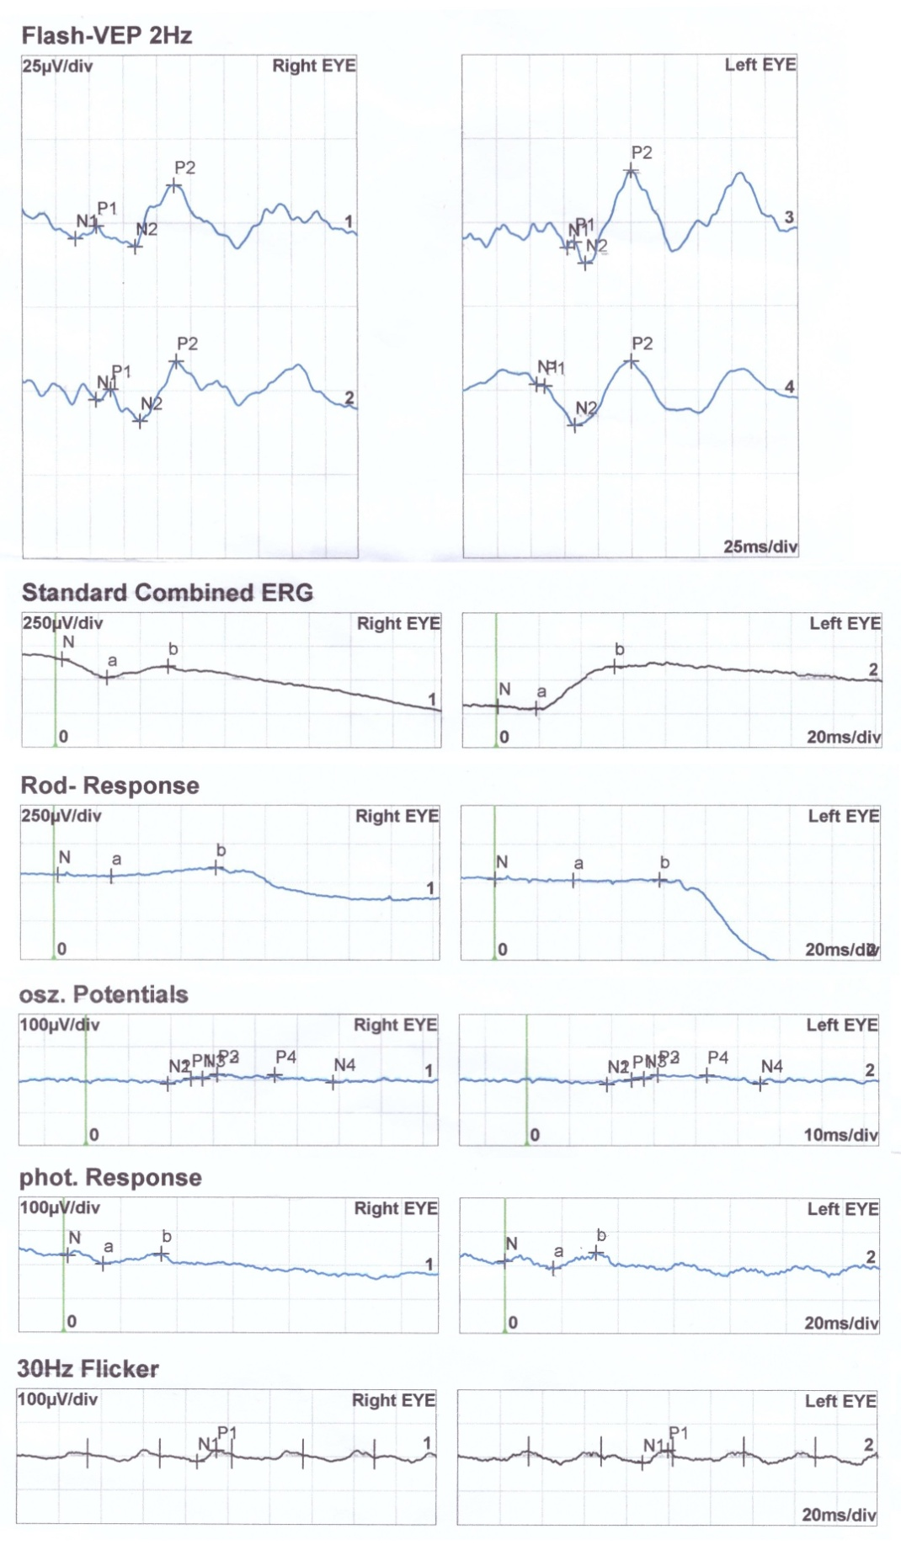
Figure S1. The visual electrophysiology examination of patient in Family 3. F-VEP shows that the latency and amplitude of P2 wave in the right eye were normal, while the latency of P2 wave in the left eye was slightly delayed and the amplitude was normal. F-ERG shows that each wavelet of the binocular OPS response was poorly differentiated, and the amplitudes of the other response were moderately and severely decreased.
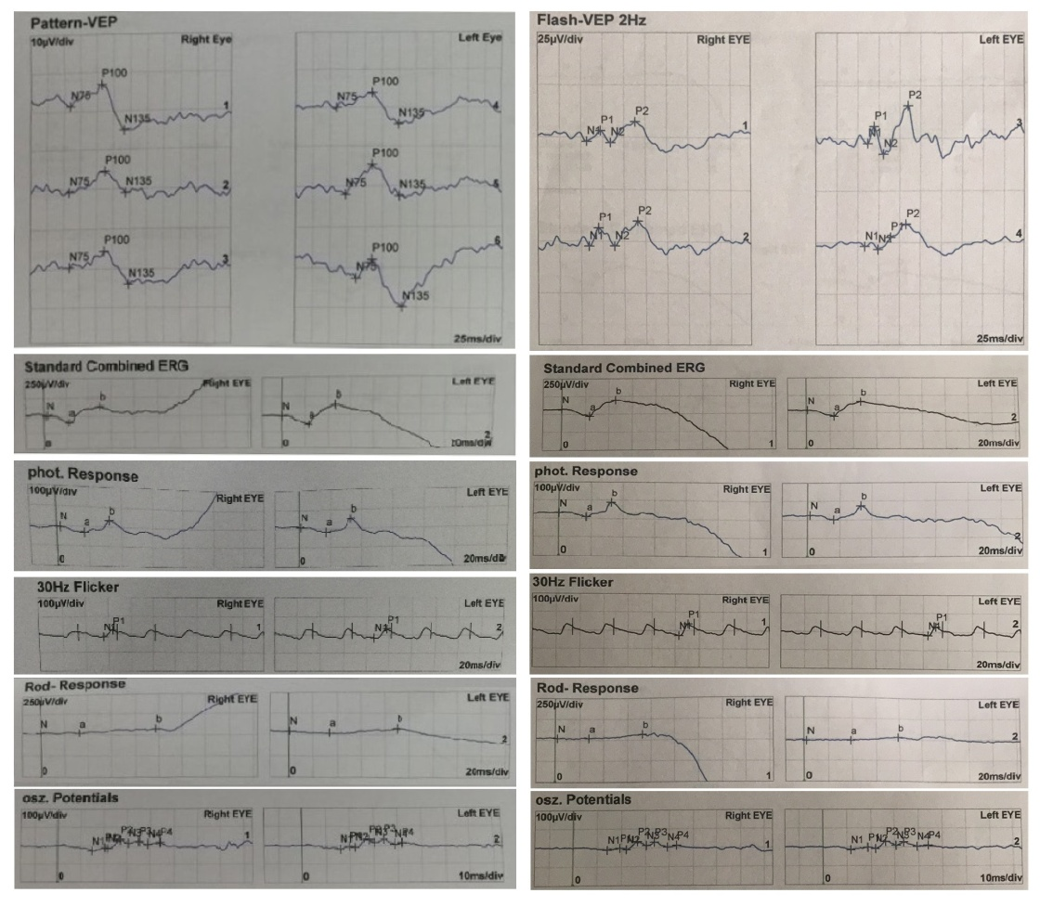
Figure S2. The examination of visual electrophysiology of patient in Family 5. P-VEP examination showed that the latency of P100 wave in both eyes was delayed and the amplitude was decreased. F-ERG examination showed that binocular rod response and 30Hz response amplitude decreased moderately or severely, other response amplitudes decreased moderately or severely.

Figure S3. The result of flash electroretinogram of patient in Family 21 showed that the amplitude of a and b wave was normal, the latency of a and b wave was prolonged, and the wave oscillating potential (ops) was increased.

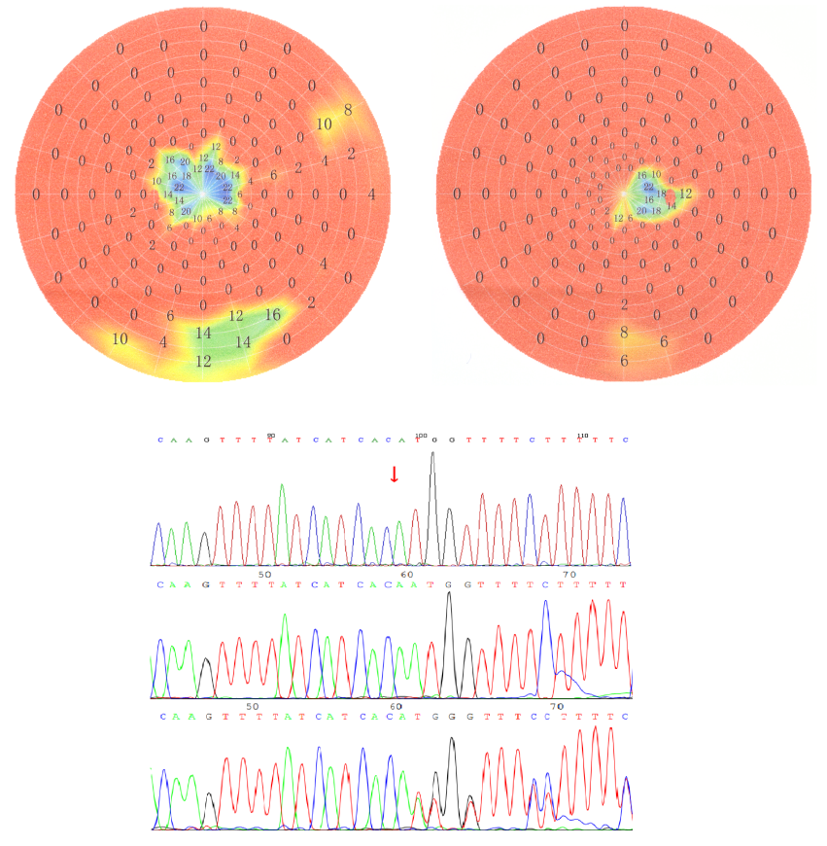
Figure S4. Visual field and Sanger sequencing of the mutation sites of the patient in Family 16
Left eye: residual visual field around the upper and lower nose, central residual visual field;
Right eye: residual visual field around the lower nose, central residual visual field

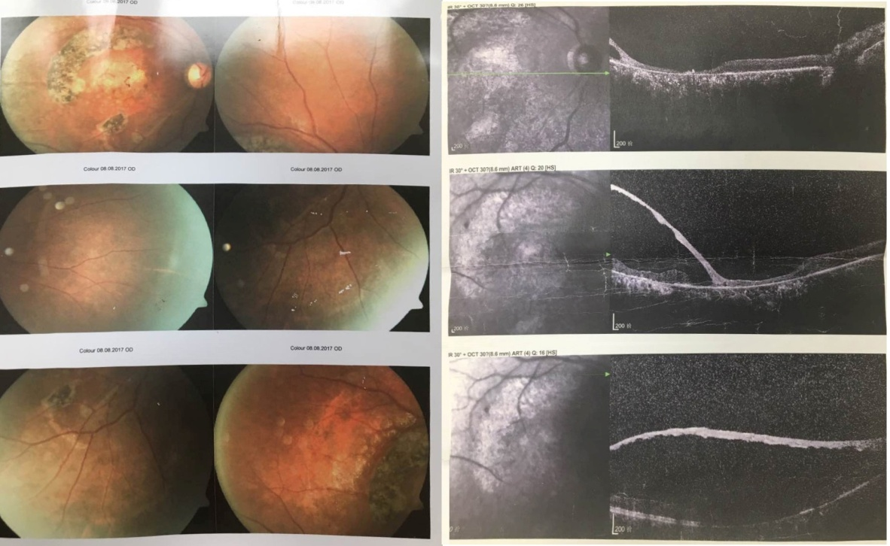
Figure S5. Fundus examination and OCT of right eye of the congenital retinoschisis patient in Family 38.

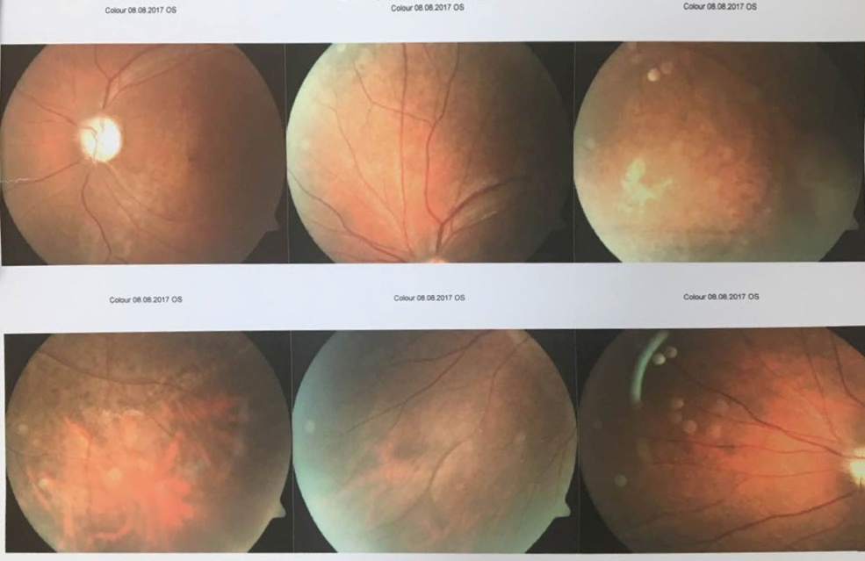
Figure S6. Fundus examination of left eye of the congenital retinoschisis patient in Family 38.

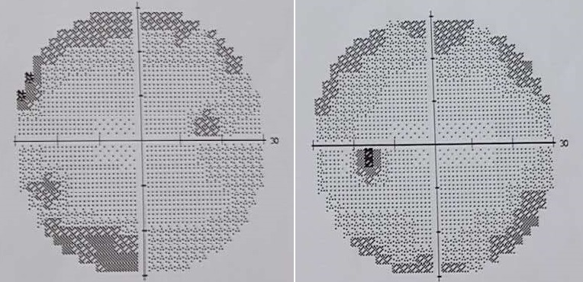
Figure S7. The younger brother with decreased binocular visual field in Family 2.

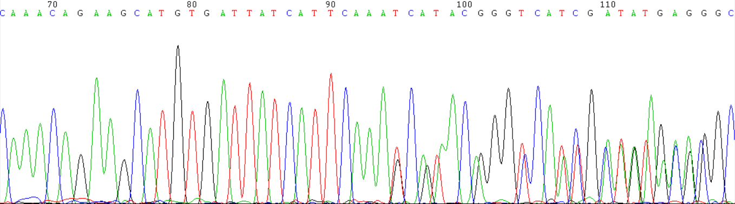
Figure S8. The CYP4V2 c.(802-8)_810delTCATACAGGTCATCGCTinsGC mutation in Family 4
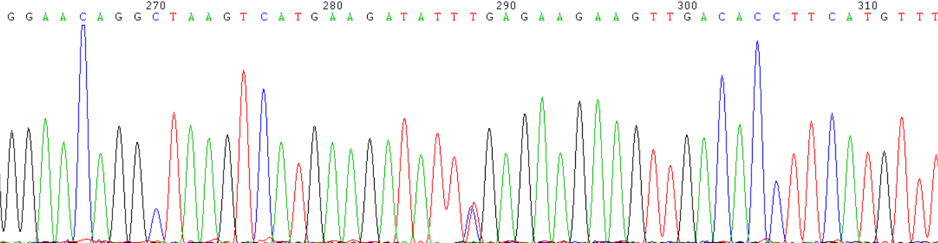
Figure S9. The CYP4V2 c.958C>T mutation in Family 4

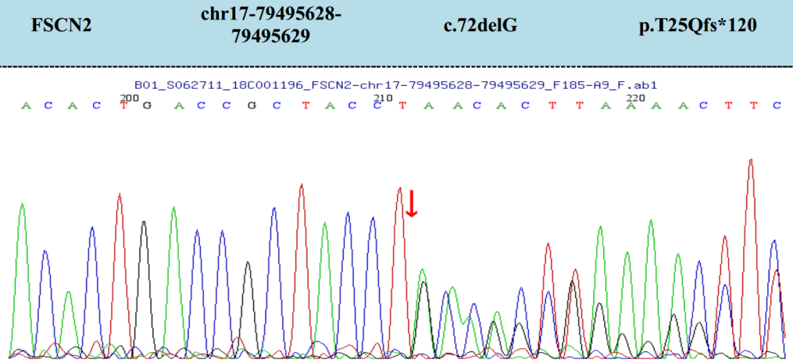
Figure S10. The FSCN2 c.72delG mutation of patient in Family 6

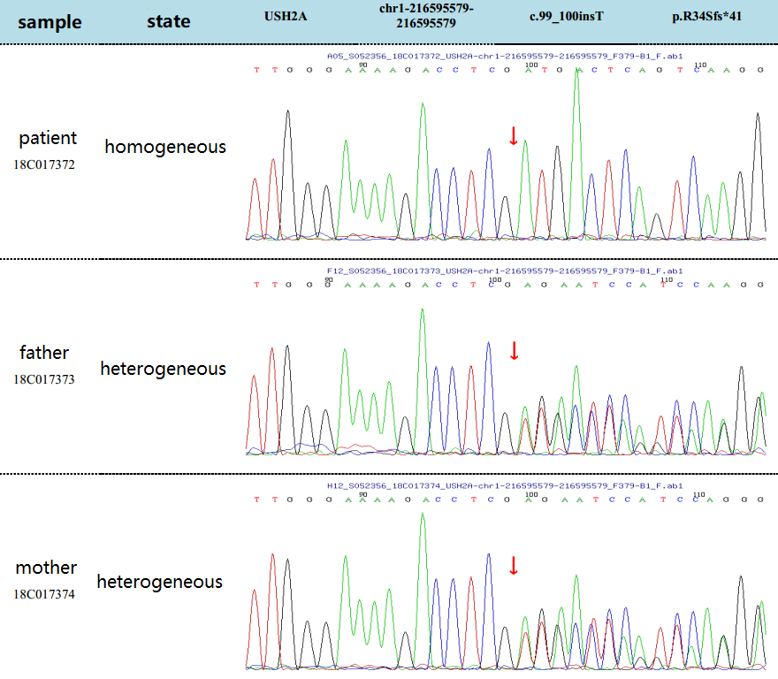
Figure S11. The USH2A c.99_100insT mutation in Family 7

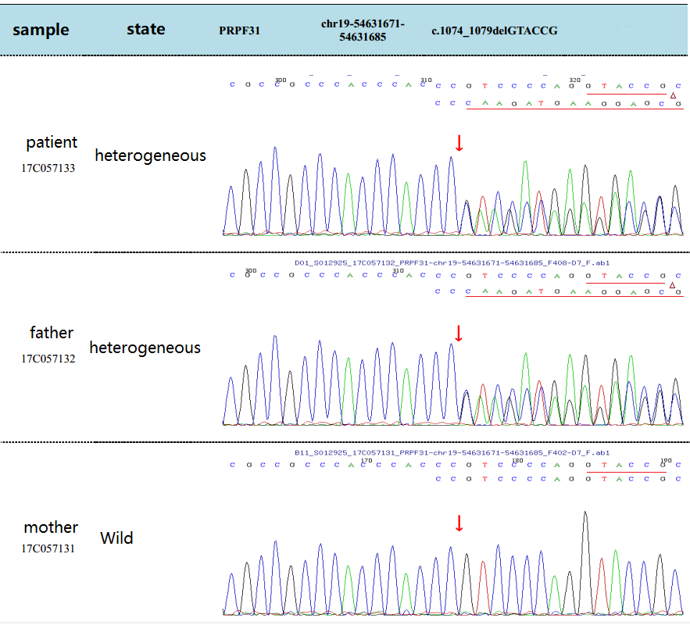
Figure S12. The PRPF31 c.1074-8_1079delGTACCGGTCCCCAG mutation in Family 12

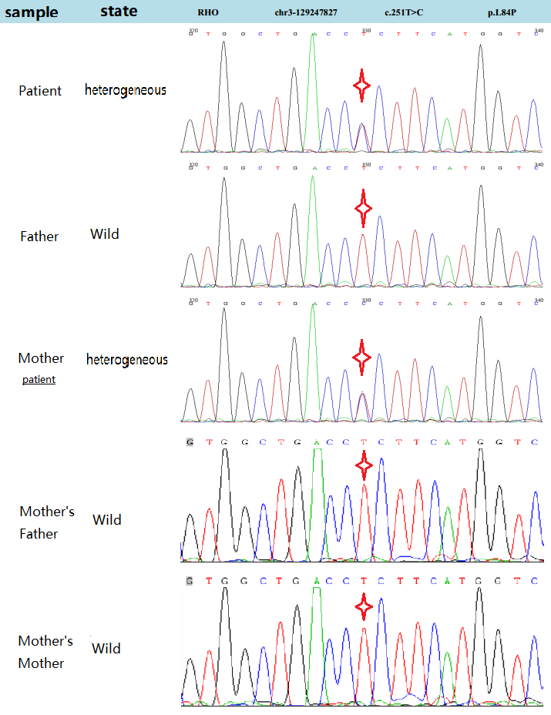
Figure S13. The RHO c.251T>C mutation in Family 14

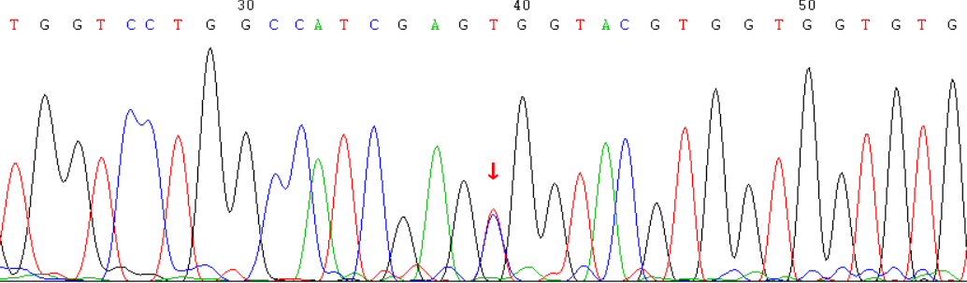
Figure S14. The RHO c.403C>T mutation in Family 15

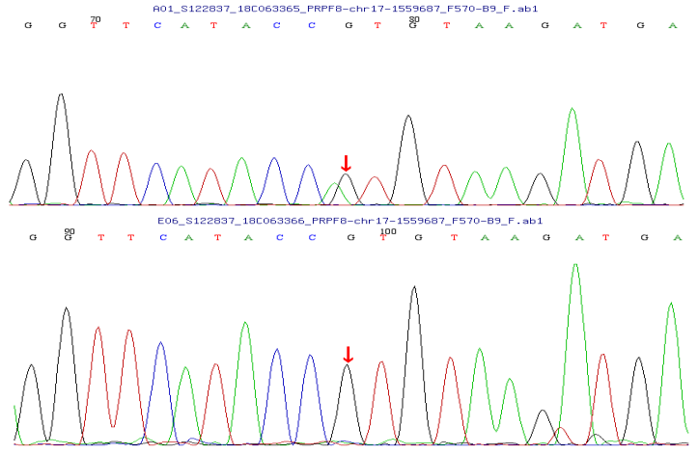
Figure S15. The PRPF8 c.5792C>T mutation in Family 17

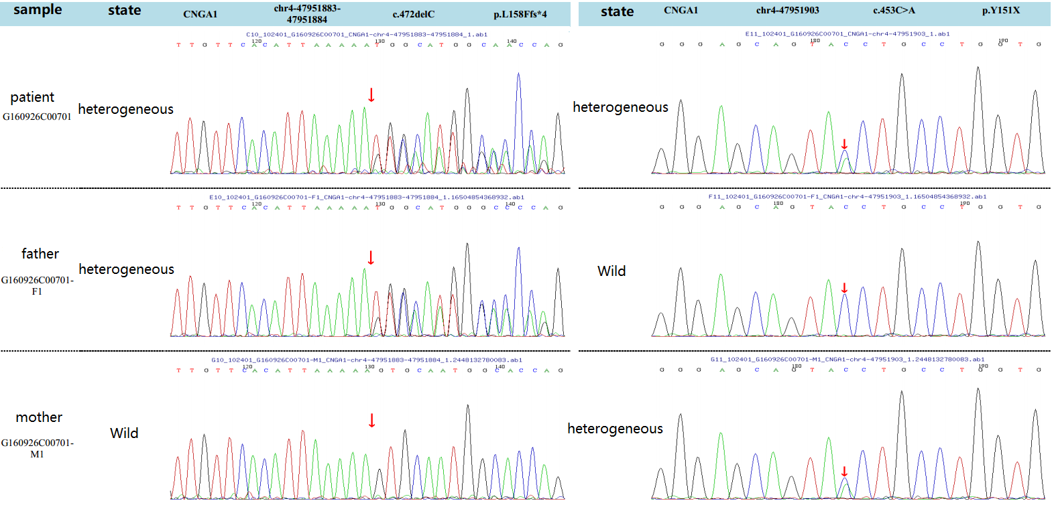
Figure S16. The CNGA1 c.472delC and c.453C>A mutation in Family 45

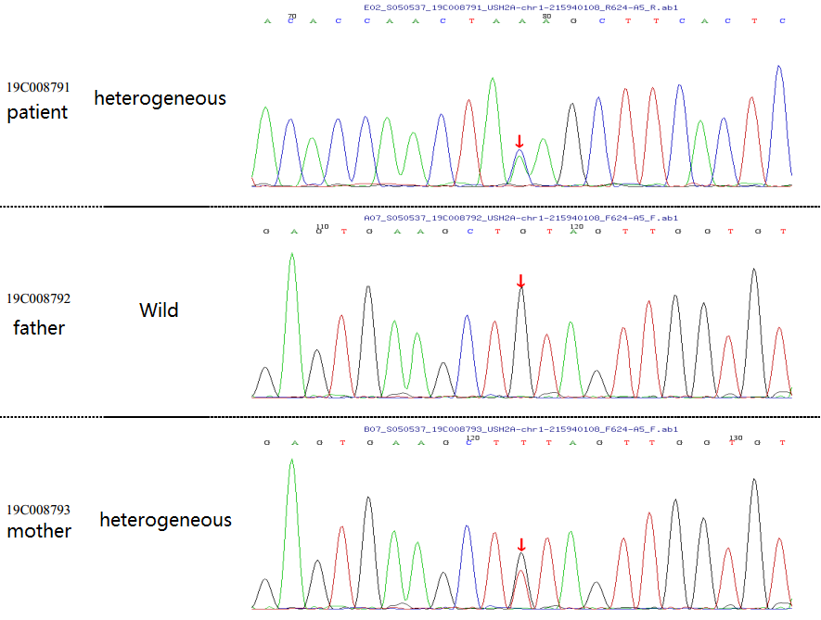
Figure S17. The USH2A c.10962C>A mutation in Family 47

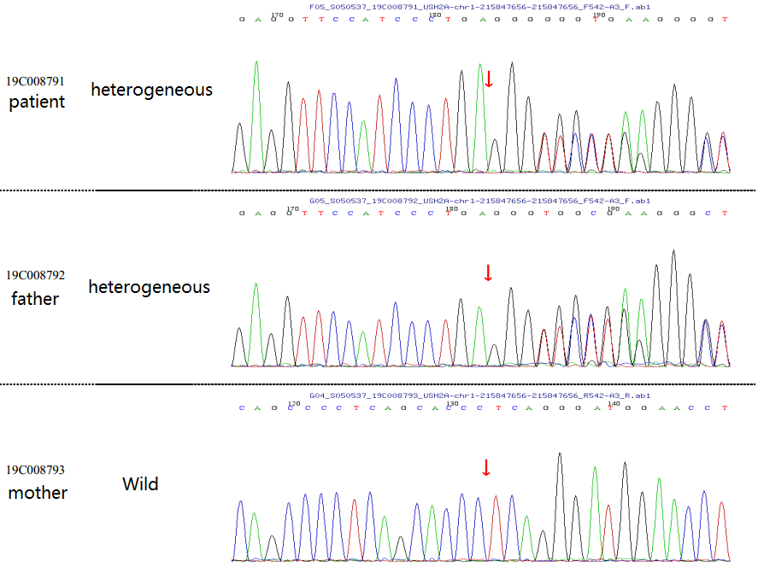
Figure S18. The USH2A c.13596dupC mutation in Family 47

Figure S19. Ophthalmoscopic examination of patient in Family 22 showed the defect of the optic disc and the retinal blood vessels radiation from peripheral optic disc. There is no abnormality in the periphery of the retina.

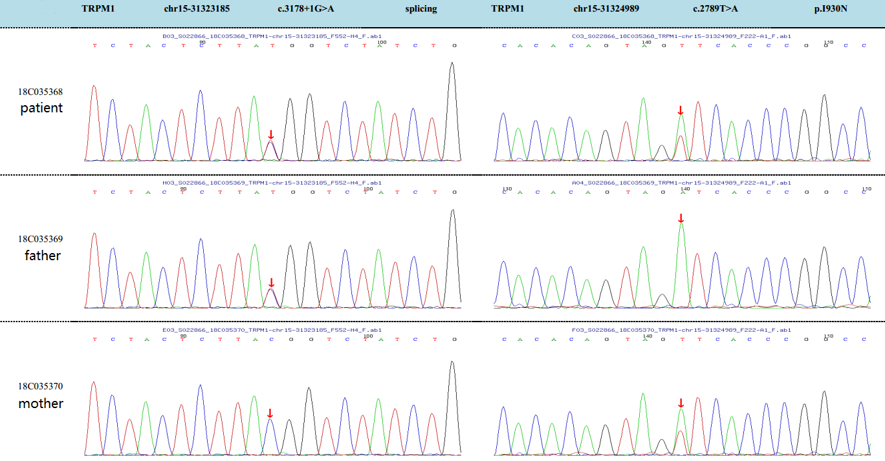
Figure S20. The TRPM1 c.3178+1G>A and c.2789T>A mutations in Family 20

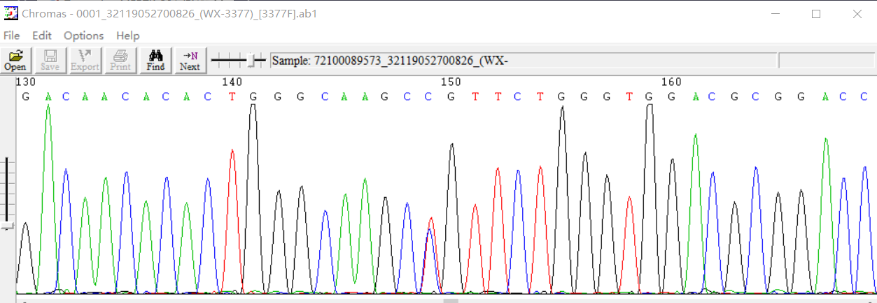
Figure S21. The LRP5 c.3377T>C mutation in Family 56

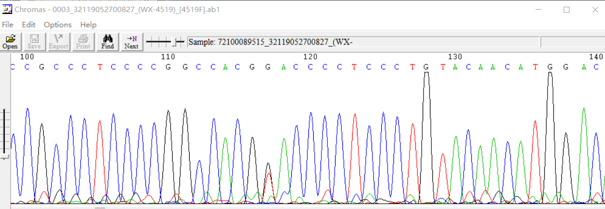
Figure S22. The LRP5 c.4519G>T mutation in Family 56

Figure S23. Part A, ophthalmoscopic examination of the patient in Family 5 showed that the RFE layer in macular area of right eye was localized thickening and bulging, and the io/os layer was localized defect. The disc color of binocular fundus was pale. Part B, OCT showed that the signal in the outer layer of the retina was not clear, the pigment epithelium was rough, and the retina exuded between layers. The binocular choroidal signal was enhanced, the right macula was irregular and the IS/OS layer was absent locally, the IS/OS layer of the left macula was blurred. Part C is the Sanger sequencing results of the mutated sites.

Figure S24. CYP4V2 mutations and clinical manifestation of the Bietti CCD patient in Family 3. Part A, a large number of crystalline substances can be seen under the neuroepithelial layer of macular area, and a large number of crystalline substances can be seen in the pigmented epithelium and choroidal layer; Part B, centripetal visual field defect; Part C, the patient with homozygous mutation of CYP4V2 c.(802-8)_810delTCATACAGGTCATCGCTinsGC; Part D, the patient’s daughter with heterozygous CYP4V2 c.(802-8)_810delTCATACAGGTCATCGCTinsGC.

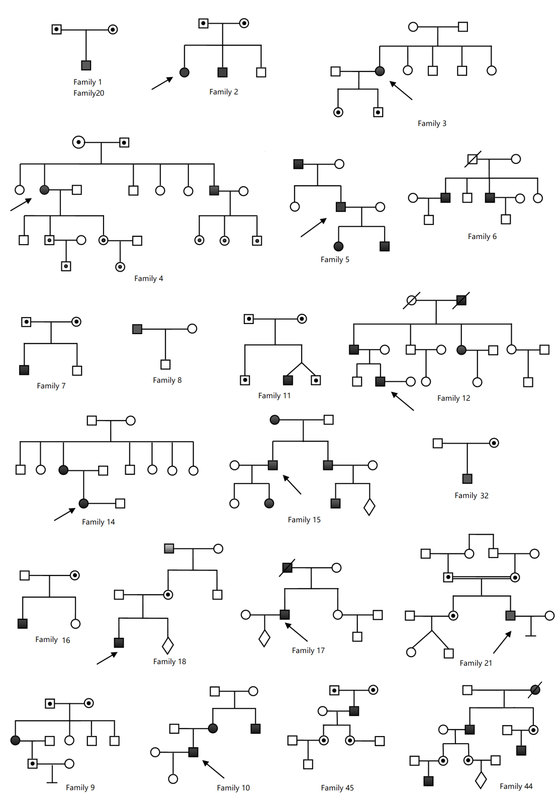
Figure S25. Partial family trees in this study

